# Background

## Context

The United States’ current trade war with China serves as a catalyst for a national debate regarding the influence of trade with China on the US manufacturing sector. Often, the rhetoric reflects pundits’ philosophical beliefs regarding globalization, the liberalization of trade, and the merits of tariffs for the United States manufacturing sector. Nationalists cite a correlation between declining manufacturing employment[1] and the granting of Permanent Normal Trade Relations (PNTR) to China, which eliminated uncertainty about China’s continued access to the U.S. market.[2] Contrarily, globalists appeal to notions of economic theory that support gains from trade and suggest that protectionist policies have an adverse impact on manufacturing.[3] Seeking to dispense with the political rhetoric, this investigation uses publicly available data to examine the influence trade with China has on United States’ manufacturing and uses these findings to forecast US manufacturing for the 2020 calendar year.

## Secondary Research

A review of publicly available existing literature on the topic yields surprisingly few quantitative forecasts. Several of the prominent forecasts include Moodys Analytics[4],[5] and the MAPI Foundation[6],[7]. Noticeably absent among these forecasts, however, are any variables related to the US interplay with China. This is surprising given that China is the largest exporter[8] to the United States and is the third largest importer.[9] By optimizing a forecast for US manufacturing, this investigation seeks to address the question of whether variables related to China have a meaningful impact on the ability to forecast US manufacturing.

## Data

The target variable this analysis seeks to forecast is “Industrial Production: Manufacturing (NAICS)” (FRED ID: IPGMFN). FRED provides the following definition:

The industrial production (IP) index measures the real output of all relevant establishments located in the United States, regardless of their ownership, but not those located in U.S. territories.

The data are indexed to the 2012=100. Independent variables include:

|  |  |  |  |
| --- | --- | --- | --- |
| **Variable** | **FRED series** | **Definition** | **Notes** |
| Economic Policy Uncertainty Index for United States | USEPUINDXM | This index is constructed from three types of underlying components.[10] |  |
| Exports: Value Goods for China | XTEXVA01CNM667S | Self-explanatory |  |
| Imports: Value Goods for China | XTIMVA01CNM667N | Self-explanatory |  |
| Monetary Base; Total | BOGMBASE | The series equals total balances maintained plus currency in circulation. |  |
| Japan / U.S. Foreign Exchange Rate | EXJPUS | Averages of daily figures. Noon buying rates in New York City for cable transfers payable in foreign currencies. |  |
| Industrial Production Index | INDPRO | The Industrial Production Index (INDPRO) is an economic indicator that measures real output for all facilities located in the United States manufacturing, mining, and electric, and gas utilities (excluding those in U.S. territories) |  |
| Important Events | N/A | See Appendix for list of major events in China-US relations | Dummy variable with 1 in months of seemingly important developments |
| Trade War dummy | N/A | A dummy variable with 1s starting in July 2018 |  |
| Trump inauguration | N/A | A dummy variable with 1s starting in January 2017 |  |

Although more historical data are available, this investigation restricts the analysis from 2010 (the year China became the 2nd largest economy in the world) to the present.

A correlation matrix examines the interactions among our variables:

|  |  |  |  |  |  |  |  |  |  |
| --- | --- | --- | --- | --- | --- | --- | --- | --- | --- |
|  | **exports** | **imports** | **EXJPUS** | **INDPRO** | **Manufacturing** | **money** | **Uncertainty** | **exports_percent_change** | **imports_percent_change** |
| **exports** | 1.00 | 0.57 | 0.62 | 0.89 | 0.82 | 0.72 | -0.42 | 0.28 | -0.08 |
| **imports** | 0.57 | 1.00 | 0.20 | 0.65 | 0.63 | 0.36 | -0.12 | -0.10 | 0.42 |
| **EXJPUS** | 0.62 | 0.20 | 1.00 | 0.71 | 0.59 | 0.84 | -0.65 | -0.05 | -0.04 |
| **INDPRO** | 0.89 | 0.65 | 0.71 | 1.00 | 0.92 | 0.76 | -0.42 | -0.05 | -0.04 |
| **Manufacturing** | 0.82 | 0.63 | 0.59 | 0.92 | 1.00 | 0.70 | -0.37 | -0.07 | 0.02 |
| **money** | 0.72 | 0.36 | 0.84 | 0.76 | 0.70 | 1.00 | -0.68 | -0.05 | -0.03 |
| **Uncertainty** | -0.42 | -0.12 | -0.65 | -0.42 | -0.37 | -0.68 | 1.00 | -0.01 | 0.07 |
| **exports_percent_change** | 0.28 | -0.10 | -0.05 | -0.05 | -0.07 | -0.05 | -0.01 | 1.00 | -0.08 |
| **imports_percent_change** | -0.08 | 0.42 | -0.04 | -0.04 | 0.02 | -0.03 | 0.07 | -0.08 | 1.00 |

## Examination of Dependent Variable

Starting shortly after The Great Recession, the time series data exhibit an upward trend.

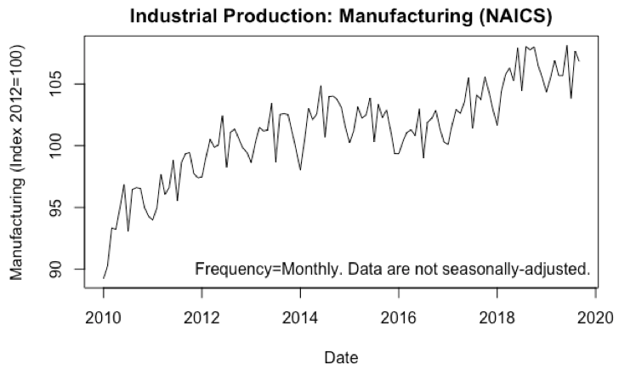

Decomposing the data reveals that the data include an upward trend and a seasonal component.

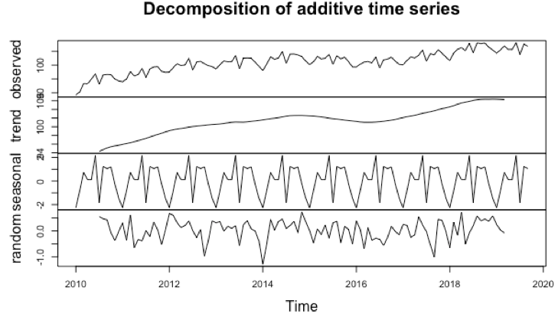

A Dickey-Fuller Test reveals that, despite the upward trend, the data are stationary for this time period, meaning the data is trend-stationary or deterministic in nature.[11]

* **H0:** a unit root is present in a time series sample
* **Ha:** data are stationarity or trend-stationarity

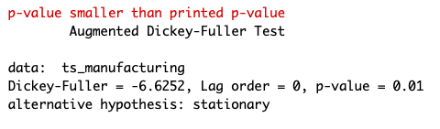

Digging a little bit deeper into the seasonality of the data, one can see from the box plot below that manufacturing seems to peak in June but then drop-off in July. It is also apparent that manufacturing seems to increase until mid-summer and also tapers off from October through December. December’s manufacturing levels remain consistent between 2010 and 2017 (years included in the training dataset).

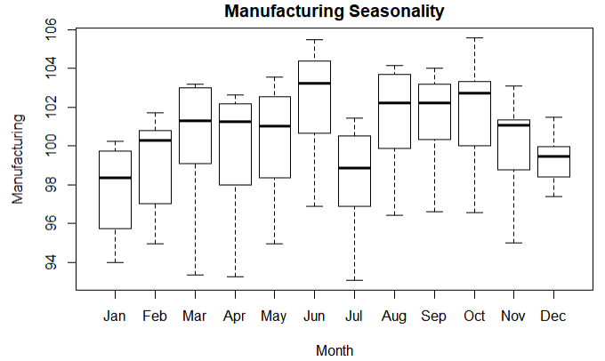

The available evidence suggests that, although the role of seasonality is diminishing in manufacturing, supply chain and consumer demand realities produce some cyclicality.[12] Indeed, a correlogram suggest seasonality in our data and autocorrelation with the value from 12 months prior. Also, given the dampening of the autocorrelation chart and the cut-off in the partial autocorrelation chart, the data are indicative of an AR process.

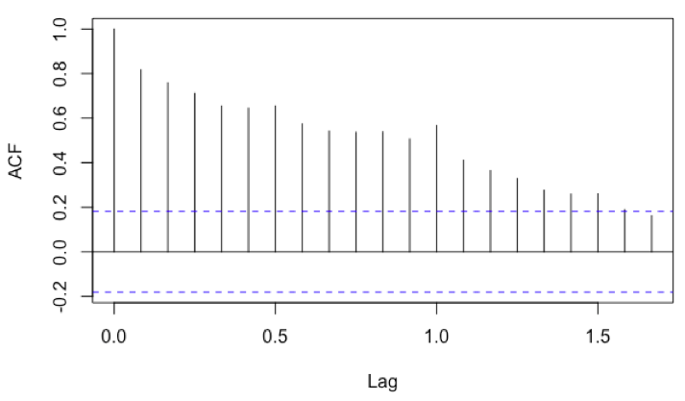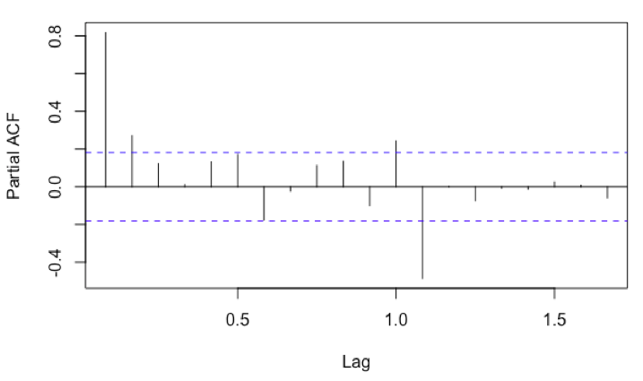

# Evaluating Forecast

## Methodology

To evaluate the efficacy of our models, we split the first 80 percent of the data into the training set (n=94)[13] and the last 20 percent into the testing set (n=23),[14] trained the model to fit the parameters on the training data, and then assessed the performance of the model on the test data. Although we found several promising models—see Appendix for a complete list of candidate models—we selected the best forecasting model based primarily using RMSE on test data, but also other considerations.[15]

## Evaluating Preferred Model

Per our criteria, the best model in this investigation is an ARIMA(1,0,1) that includes seasonal dummies and INDPRO as exogenous variables. 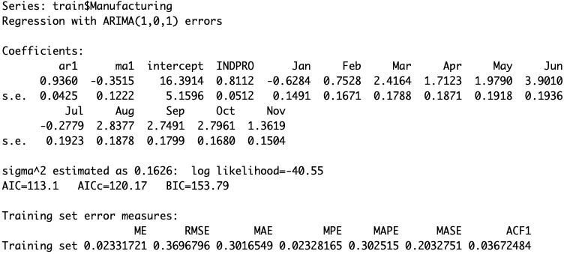

A summary of test statistics on the training data include:

* AIC=113.1
* BIC=153.79
* RMSE=0.3696796

Forecasting the model on the test data reveals a close approximation of the actual data (rmse= 0.7846745).

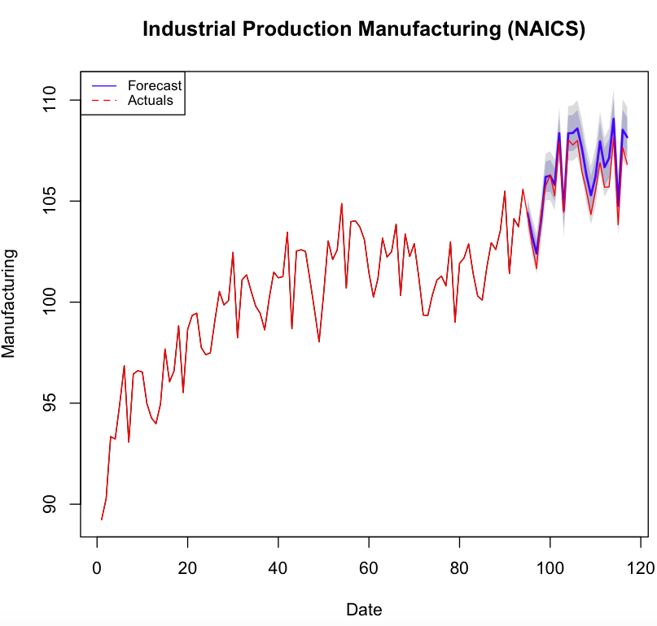

The residual plot suggests that our model overestimates the true series slightly. Incidentally, this period coincides with the beginning of the Trump administration’s Trade War with China (July 2018). (We hoped to test for the impact of the trade war using a structural break, but the entire structural break occurs in our test set, so we cannot train our model using it.)

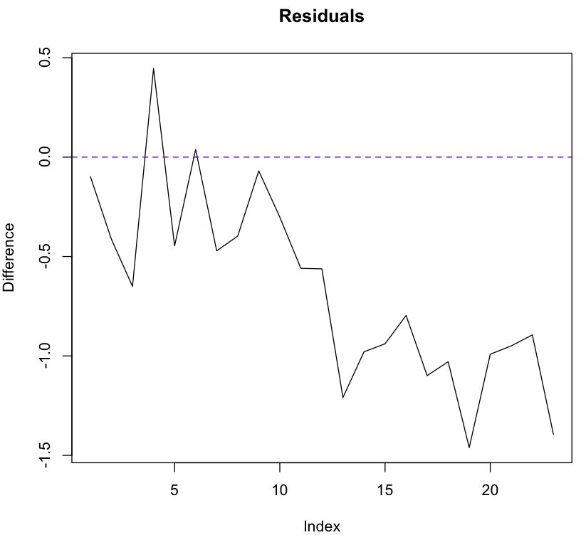

We perform a Ljung-Box Test to assess that the residuals from a time series model resemble white noise.

* **H0:** The data are independently distributed
* **Ha:** The data are not independently distributed; they exhibit serial correlation.’

The results suggest that there is serial correlation in our residuals.

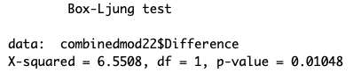

Moreover, the correlogram of the residuals suggests there may be some pattern (e.g., additional seasonality) in our residuals.

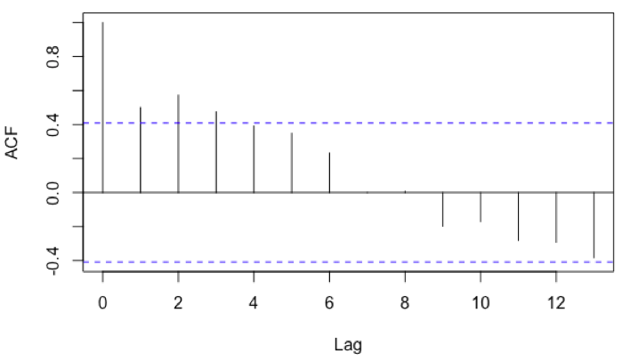 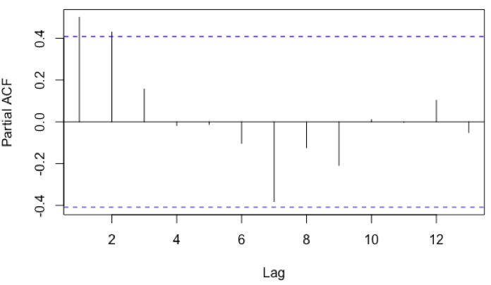

Although this is less than ideal, we feel that the test set is too small (n=23) to conclude that there is a problematic pattern in the residuals.

## Reasons for *Not* Using Other Models

Although the forecasting RMSE (0.7560797) is lower for an ARIMA(1,0,1) that also includes imports and exports, those two variables seemingly do not impact the model (estimates for coefficients are 0) (although the estimates for coefficients for the other models do change).

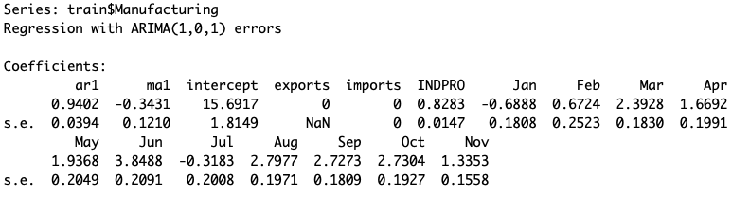

Moreover, the lower RMSE is not significantly better per the Diebold-Mariano test for predictive accuracy.[16]

We also tried several VARs models, but these had significantly lower predictive accuracy than did our ARIMA models.

All of the other ARIMA models with a reasonably low number of lags performed well (rmse in .8-1 range) but had worse predictive accuracy per the Diebold-Mariano test. Moreover, they displayed similar patterns in the residuals—this leads us to believe that there is a structural break (e.g., the Trade War) affecting our data that we are unable to model.

# Forecasting Through 2020

Because we use exogenous variables in our model, we need to project these variables through 2020. The seasonal dummies are predictable, but we used a simple arima model to forecast our INDPRO variable.

# Conclusion

# Appendix

## Important Events in China and United States Relations

The Council of Foreign Relations identifies important events and developments in United States and Chinese relations.[17]

* August 2010: China becomes world’s second-largest economy
* November 2011: In an essay for Foreign Policy, U.S. Secretary of State Hillary Clinton outlines a U.S. “pivot” to Asia.
* March 2012: the United States, the EU, and Japan file a “request for consultations” with China at the World Trade Organization over its restrictions on exporting rare earth metals.
* November 2012: Xi Jinping replaces Hu Jintao as president
* June 2013: Sunnylands Summit
* May 2014: A U.S. court indicts five Chinese hackers, allegedly with ties to China’s People’s Liberation Army, on charges of stealing trade technology from U.S. companies
* May 2015: U.S. Warns China Over South China Sea
* February 2017: U.S. President Donald J. Trump says he will honor the One China policy
* April 2017: Trump Hosts Xi at Mar-a-Lago
* March 2018: The Trump administration announces tariffs on Chinese imports, worth at least $50 billion, in response to what the White House alleged is Chinese theft of U.S. technology and intellectual property.
* July 2018: The Trump administration imposes new tariffs totaling $34 billion worth of Chinese goods
* October 2018: U.S. Vice President Mike Pence delivers a speech marking the clearest articulation yet of the Trump administration’s policy toward China and a significant hardening of the United States’ position.
* December 2018: Meng Wanzhou, the chief financial officer of Chinese telecom and electronics company Huawei, is arrested in Canada at the United States’ request.
* March 2019: Huawei sues the United States
* May 2019: The Trump administration raises tariffs from 10 to 25 percent on $200 billion worth of Chinese goods.
* August 2019: U.S. labels China a currency manipulator

## The Diebold-Mariano Test Results

* **H0:** The null hypothesis is that the two forecasts have the same accuracy.
* **Ha:** The alternative hypothesis is that the two forecasts have different levels of accuracy.

|  |  |  |  |  |
| --- | --- | --- | --- | --- |
| **Model 1** | **Model 2** | **RMSE 1** | **RMSE 2** | **DM p-value** |
| ARIMA(3,0,0) | ARIMA(3,0,0) | 0.8164485 | 0.820713 | 0.521 |
| ARIMA(1,0,1) | ARIMA(3,0,0) | 0.7560797 | 0.820713 | .082e-06 |
| ARIMA(1,0,1) | ARIMA(3,0,0) | 0.7560797 | 0.8164485 | 0.0001461 |

## Summary of Models Tried

|  |  |  |  |  |  |
| --- | --- | --- | --- | --- | --- |
| **Model description** | **Exogenous variables** | **Endogenous** | **AIC on training data** | **BIC/SIC on training data** | **RMSE on forecasting data** |
| ARIMA(0,1,1) with drift | none |  | 363.04 | 370.64 | 1.632042 |
| ARIMA(0,1,1) with drift | Seasonal dummies |  | 174.24 | 209.7 | 0.8984404 |
| ARIMA(0,1,0) with drift | -Seasonal dummies -imports |  | 173.14 | 208.6 | 0.9689963 |
| ARIMA(1,1,0) | -Seasonal dummies -exports |  | 175.77 | 213.76 | 0.920572 |
| ARIMA(1,1,0) | -Seasonal dummies -US/Japan Exchange rate |  | 176.23 | 214.21 | 0.8974932 |
| ARIMA(3,0,0) | -Seasonal dummies -Industrial production |  | 113.85 | 157.09 | 0.820713 |
| ARIMA(0,0,4) | -Seasonal dummies -money supply |  | 227.72 | 273.5 | 4.9288106 |
| ARIMA(0,1,1) | -Seasonal dummies -uncertainty |  | 174.99 | 212.98 | 0.9188265 |
| ARIMA(3,0,0) | -Seasonal dummies -Industrial production -exports |  | 114.74 | 160.52 | 0.8164485 |
| ARIMA(3,0,0) | -Seasonal dummies -Industrial production -exports -uncertainty |  | 115.98 | 126.25 | 0.8470702 |
| vars, 1 lags | Seasonal dummies with trend | Uncertainty, Industrial Production |  |  | 3.470713 |
| vars, 10 lags | Seasonal dummies with trend | Uncertainty, Industrial Production, China Import, China Import |  |  | 2.841961 |
| vars, 1 lag | Seasonal dummies with trend; Trump's inauguration | Industrial Production, US-JP Exchange Rate |  |  | 1.613578 |
| vars, 1 lag | Seasonal dummies with trend; Trump's inauguration | Industrial Production, US-CH Exchange Rate |  |  | 1.655726 |
| vars, 1 lag | Seasonal dummies with trend; Trump's inauguration | Industrial Production, US-CH Exchange Rate, Uncertainty |  |  | 1.669066 |
| vars, 1 lag | Seasonal dummies with trend; Trump's inauguration | Industrial Production |  |  | 2.220434 |
| ARIMA(0,1,1) | -Seasonal dummies -percent change in exports |  | 176.19 | 214.18 | 0.8967076 |
| ARIMA(0,1,1) | -Seasonal dummies -percent change in imports |  | 174.6 | 212.58 | 0.8885765 |
| ARIMA(0,1,1) | -Seasonal dummies -important events |  | 176.19 | 214.17 | 0.9001211 |
| ARIMA(3,0,0) | none |  | 373.75 | 374.44 |  |
| ARIMA(1,0,1) | none |  | 370.72 | 380.85 |  |
| ARIMA(1,0,1) | • Seasonal dummies | | 179.22 | 217.21 |  |
| ARIMA(1,0,1) | • Seasonal dummies • INDPRO |  | 111.45 | 151.98 |  |
| ARIMA(1,1,1) | • Seasonal dummies • INDPRO |  | 108.79 | 146.62 |  |
| ARIMA(1,0,1) | • Seasonal dummies • INDPRO • Exports |  | 112.18 | 155.24 |  |
| ARIMA(1,1,1) | • Seasonal dummies • INDPRO • Exports |  | 109.46 | 149.81 |  |
| ARIMA(1,0,1) | • Seasonal dummies • INDPRO • Exports • Imports |  | 113.75 | 159.33 |  |
| ARIMA(1,1,1) | • Seasonal dummies • INDPRO • Exports • Imports |  | 110.6 | 153.48 |  |
| ARIMA(1,0,1) | • Seasonal dummies • INDPRO • Exports • Money |  | 124.91 | 170.5 |  |
| ARIMA(1,1,1) | • Seasonal dummies • INDPRO • Exports • Money |  | 108.56 | 151.43 |  |
| ARIMA(1,0,1) | • Seasonal dummies • INDPRO • Exports • Imports • Money |  | 127.81 | 175.93 |  |
| ARIMA(1,1,1) | • Seasonal dummies • INDPRO • Exports • Imports • Money |  | 110.24 | 155.63 |  |
| ARIMA(1,1,1) | • Seasonal dummies • INDPRO |  | 110.58 | 148.57 | 0.948678 |
| ARIMA(1,1,1) | • Seasonal dummies • INDPRO • Exports • Money |  | 109.84 | 152.89 | 1.334426 |
| ARIMA(1,1,1) | • Seasonal dummies • INDPRO • Exports • Imports • Money |  | 111.58 | 157.17 | 1.2929002 |
| ARIMA(1,1,1) | • Seasonal dummies • INDPRO • Exports |  | 111.1 | 151.62 | 0.9321215 |
| ARIMA(3,0,0) | • Seasonal dummies • INDPRO |  | 113.85 | 157.09 | 0.820713 |
| ARIMA(3,0,0) | • Seasonal dummies • INDPRO • Exports • Money |  | 115.34 | 163.66 | 1.0830019 |
| ARIMA(3,0,0) | • Seasonal dummies • INDPRO • Exports • Imports • Money |  | 117.08 | 167.95 | 1.046821 |
| ARIMA(3,0,0) | • Seasonal dummies • INDPRO • Exports |  | 114.74 | 160.52 | 0.8164485 |
| vars, p=1 | -INDPRO -Manufacturing |  | -0.6448424 |  | 2.90223 |
| vars, p=2 | -seasonal dummies | -INDPRO -Manufacturing |  |  | 2.51122 |
| vars, p=3 |  | -manufacturing -INDPRO -imports -exports |  |  | 3.025255 |
| vars, p=8 | -seasonal dummies -exports -imports | -manufacturing -INDPRO |  |  | 2.344494 |
| ARIMA(1,0,1) | -Seasonal dummies  -Industrial production -exports -imports |  | 115.26 | 161.04 | 0.7560797 |
| ARIMA(1,0,1) | -Seasonal dummies  -Industrial production -exports -imports -Trump inauguration |  | 116.12 | 164.44 | 0.840877 |
| ARIMA(1,0,1) | -Seasonal dummies  -Industrial production |  | 113.1 | 153.79 | 0.7846745 |

1. “All Employees, Manufacturing (MANEMP).” *Federal Reserve Board of St. Louis*, 2019, fred.stlouisfed.org/series/MANEMP.
2. Salam, Reihan. “Normalizing Trade Relations With China Was a Mistake.” *The Atlantic*, 8 June 2018, www.theatlantic.com/ideas/archive/2018/06/normalizing-trade-relations-with-china-was-a-mistake/562403/.
3. Behsudi, Adam, and Finbarr Bermingham. “Trump Thinks Tariffs Will Add U.S. Manufacturing Jobs. Economic Reality Says They Won't.” POLITICO, 22 Aug. 2019, www.politico.com/story/2019/08/21/trump-tariffs-bikes-manufacturing-1470361.
4. “United States - Industrial Production.” Moody's, 2019, www.economy.com/united-states/industrial-production.
5. Variables include Purchasing Managers index, Business Confidence, Capacity Utilization, Industrial Production, Change in Inventories, and Real Change in Inventories
6. “Forecast Methodology.” MAPI Foundation, 2019, mapifoundation.org/methodology-march-2018.
7. Variables include Aggregate GDP growth of non-U.S. advanced economies, Aggregate GDP growth of 26 major developing economies, U.S. dollar versus an average of advanced economy currencies, U.S. dollar versus a basket of developing economy currencies, and capital equipment investment.
8. Waksman, Karen. “Here's a Look at the Top Countries Exporting to the United States.” The Balance Small Business, The Balance Small Business, 24 Dec. 2018, www.thebalancesmb.com/top-countries-exporting-to-the-u-s-3502318.
9. Waksman, Karen. “Which Countries Import the Most U.S. Goods and Services Annually?” The Balance Small Business, The Balance Small Business, 30 Nov. 2019, www.thebalancesmb.com/top-countries-that-import-u-s-products-3502316.
10. “US Monthly EPU Index.” *Economic Policy Uncertainty*, 2012, www.policyuncertainty.com/us_monthly.html.
11. The test statistic and p value for the Dickey Fuller Test vary depending on the length of the time period.
12. Hoey, Brian. “A Time for Everything: Seasonality in Modern Manufacturing.” Supply Chain and Sales and Operations Planning Software - Flexis AG, 27 Feb. 2018, blog.flexis.com/a-time-for-everything-seasonality-in-modern-manufacturing-.
13. January 2010 through October 2017
14. November 2017 through September 2019
15. Examples include AIC/SIC on training model, evaluating patterns in the residuals (e.g., patterns in correlogram, Ljung-Box test), economic intuition, and parsimony principle.
16. Test results are in the Appendix.
17. “Timeline: U.S. Relations with China.” *Council on Foreign Affairs*, 2019, www.cfr.org/timeline/us-relations-china.